LAB MANUAL
CSA0411-OPERATING SYSTEM

EXPERIMENT 1:
PROCESS CREATION USING SYSTEM CALLS
AIM:
To create a new process using the fork() system call and display the Process ID and Parent Process ID using a C program.
CODE:
#include <stdio.h>
#include <unistd.h>
#include <sys/wait.h>
int main()
{
printf("Process ID: %d\n", getpid());
printf("Parent Process ID: %d\n", getppid());
fflush(stdout);
int pid = fork();
if(pid == 0)
printf("Child Process Created Successfully\n");
else if(pid > 0)
wait(NULL);
return 0;
}

OUTPUT:
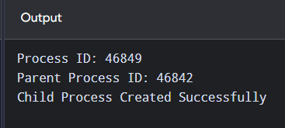
RESULT:
Thus, the process creation using system calls was successfully implemented using a C program.
EXPERIMENT 2:
FILE COPY USING SYSTEM CALLS
AIM:
To write a C program to copy the contents of one file to another using system calls.
CODE:
#include <stdio.h>
#include <fcntl.h>
#include <unistd.h>
int main()
{
int a, b, n;
char s[50], d[50], buf[100];
printf("Enter source file: ");
scanf("%49s", s);
printf("Enter destination file: ");
scanf("%49s", d);
a = open(s, O_RDONLY);
if(a < 0)
{
printf("Source file not found\n");
return 1;
}
b = open(d, O_WRONLY | O_CREAT | O_TRUNC, 0644);
if(b < 0)
{
close(a);
return 1;
}
while((n = read(a, buf, sizeof(buf))) > 0)
write(b, buf, n);
printf("\nContents copied to %s\n", d);
close(a);
close(b);
return 0;
}
OUTPUT:
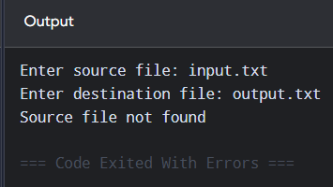
RESULT:
Thus, the contents of one file were successfully copied to another file using system calls in C.

EXPERIMENT 3:
First Come First Served (FCFS) Scheduling
AIM:
To implement the First Come First Served (FCFS) CPU scheduling algorithm using a C program, assuming all processes arrive at time 0 and do not wait for I/O.
CODE:
#include <stdio.h>
int main()
{
int bt[]={5,3,2}, wt[3], tat[3];
float aw=0, at=0;
wt[0]=0;
for(int i=0;i<3;i++)
{
if(i>0)
wt[i]=wt[i-1]+bt[i-1];
tat[i]=wt[i]+bt[i];
aw+=wt[i];
at+=tat[i];
}
printf("Process BT WT TAT\n");
for(int i=0;i<3;i++)
printf("P%d %d %d %d\n",
i+1,bt[i],wt[i],tat[i]);
printf("Average WT = %.2f\n",aw/3);
printf("Average TAT = %.2f\n",at/3);
return 0;
}
OUTPUT:
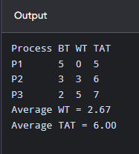
RESULT:
Thus, the First Come First Served (FCFS) CPU scheduling algorithm was successfully implemented using a C program.

EXPERIMENT 4:
TCP SOCKET PROGRAMMING FOR CLIENT–SERVER COMMUNICATION
AIM:
To implement client–server communication using TCP socket programming in C.
CODE:
SERVER PROGRAM (server.c)
#include <stdio.h>
#include <string.h>
#include <unistd.h>
#include <arpa/inet.h>
int main()
{
int s, c;
struct sockaddr_in server;
char buffer[100] = {0};
s = socket(AF_INET, SOCK_STREAM, 0);
server.sin_family = AF_INET;
server.sin_addr.s_addr = INADDR_ANY;
server.sin_port = htons(8080);
bind(s, (struct sockaddr *)&server, sizeof(server));
listen(s, 5);
printf("Server waiting for client...\n");
c = accept(s, NULL, NULL);
recv(c, buffer, sizeof(buffer), 0);
printf("Client: %s\n", buffer);
send(c, "Hello from Server", 18, 0);
close(c);
close(s);
return 0;
}
CLIENT PROGRAM (client.c)
#include <stdio.h>
#include <string.h>
#include <unistd.h>
#include <arpa/inet.h>
int main()
{
int s;
struct sockaddr_in server;
char buffer[100] = {0};
s = socket(AF_INET, SOCK_STREAM, 0);
server.sin_family = AF_INET;
server.sin_port = htons(8080);
server.sin_addr.s_addr = inet_addr("127.0.0.1");
connect(s, (struct sockaddr *)&server, sizeof(server));
send(s, "Hello from Client", 18, 0);
recv(s, buffer, sizeof(buffer), 0);
printf("Server: %s\n", buffer);
close(s);
return 0;
}
OUTPUT:
Server Output:
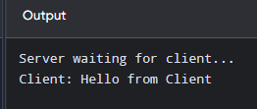
Client Output:
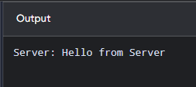
RESULT:
Thus, TCP socket programming for client–server communication was successfully implemented using C.

EXPERIMENT 5:
JAVA PROGRAMMING FOR MULTITHREADING
AIM:
To implement multithreading in Java by creating and executing multiple threads using the Thread class.
CODE:
class MyThread extends Thread
{
public void run()
{
for(int i=1; i<=5; i++)
{
System.out.println(getName()+" : "+i);
try
{
Thread.sleep(500);
}
catch(InterruptedException e)
{
System.out.println(e);
}
}
}
}
public class Main
{
public static void main(String[] args)
{
MyThread t1 = new MyThread();
MyThread t2 = new MyThread();
t1.setName("Thread 1");
t2.setName("Thread 2");
t1.start();
t2.start();
}
}
OUTPUT:
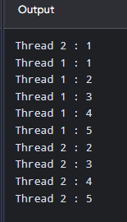
RESULT:
Thus, Java multithreading was successfully implemented using the Thread class.

EXPERIMENT 6:
First Come First Served (FCFS) Scheduling
AIM:
To implement the First Come First Served (FCFS) CPU scheduling algorithm using a C program, assuming all processes arrive at time 0 and do not wait for I/O.
CODE:
#include <stdio.h>
int main()
{
int bt[]={5,3,2}, wt[3], tat[3];
float aw=0, at=0;
wt[0]=0;
for(int i=0;i<3;i++)
{
if(i>0)
wt[i]=wt[i-1]+bt[i-1];
tat[i]=wt[i]+bt[i];
aw+=wt[i];
at+=tat[i];
}
printf("Process BT WT TAT\n");
for(int i=0;i<3;i++)
printf("P%d %d %d %d\n",
i+1,bt[i],wt[i],tat[i]);
printf("Average WT = %.2f\n",aw/3);
printf("Average TAT = %.2f\n",at/3);
return 0;
}
OUTPUT:
RESULT:
Thus, the First Come First Served (FCFS) CPU scheduling algorithm was successfully implemented using a C program.

EXPERIMENT 7:
PREEMPTIVE PRIORITY SCHEDULING
AIM:
To implement the Preemptive Priority CPU Scheduling algorithm using a C program.
CODE:
#include <stdio.h>
int main()
{
int at[]={0,2}, bt[]={5,3}, pr[]={2,1};
int rem[]={5,3}, ct[2], wt[2], tat[2];
int t=0, done=0, p;
float aw=0, avg=0;
while(done<2)
{
p=-1;
for(int i=0;i<2;i++)
{
if(at[i]<=t && rem[i]>0)
{
if(p==-1 || pr[i]<pr[p])
p=i;
}
}
if(p==-1)
{
t++;
continue;
}
rem[p]--;
t++;
if(rem[p]==0)
{
ct[p]=t;
done++;
}
}
printf("Process AT BT Priority WT TAT\n");
for(int i=0;i<2;i++)
{
tat[i]=ct[i]-at[i];
wt[i]=tat[i]-bt[i];
printf("P%d %d %d %d %d %d\n",
i+1,at[i],bt[i],pr[i],wt[i],tat[i]);
aw+=wt[i];
avg+=tat[i];
}
printf("\nAverage WT = %.2f\n",aw/2);
printf("Average TAT = %.2f\n",avg/2);
return 0;
}
OUTPUT:
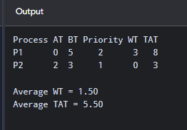
RESULT:
Thus, the Preemptive Priority CPU Scheduling algorithm was successfully implemented using a C program.

EXPERIMENT 8:
NON-PREEMPTIVE SJF SCHEDULING
AIM:
To implement the Non-Preemptive Shortest Job First (SJF) CPU Scheduling algorithm using a C program.
CODE:
#include <stdio.h>
int main()
{
int at[]={0,0,0}, bt[]={5,3,2};
int done[3]={0}, wt[3], tat[3];
int t=0, completed=0, p;
float aw=0, avg=0;
while(completed<3)
{
p=-1;
for(int i=0;i<3;i++)
{
if(!done[i] && at[i]<=t)
{
if(p==-1 || bt[i]<bt[p])
p=i;
}
}
if(p==-1)
{
t++;
continue;
}
wt[p]=t-at[p];
t+=bt[p];
tat[p]=t-at[p];
done[p]=1;
completed++;
}
printf("Process AT BT WT TAT\n");
for(int i=0;i<3;i++)
{
printf("P%d %d %d %d %d\n",
i+1,at[i],bt[i],wt[i],tat[i]);
aw+=wt[i];
avg+=tat[i];
}
printf("\nAverage WT = %.2f\n",aw/3);
printf("Average TAT = %.2f\n",avg/3);
return 0;
}
OUTPUT:
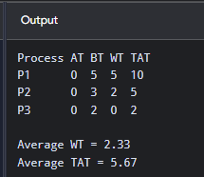
RESULT:
Thus, the Non-Preemptive Shortest Job First (SJF) CPU Scheduling algorithm was successfully implemented using a C program.

EXPERIMENT 9:
ROUND ROBIN SCHEDULING
AIM:
To implement the Round Robin CPU Scheduling algorithm using a C program with a fixed time quantum.
CODE:
#include <stdio.h>
int main()
{
int n=3, bt[]={5,3,2}, rem[]={5,3,2};
int wt[3], tat[3], q=2, t=0, done;
float aw=0, at=0;
do
{
done=1;
for(int i=0;i<n;i++)
{
if(rem[i]>0)
{
done=0;
if(rem[i]>q)
{
t+=q;
rem[i]-=q;
}
else
{
t+=rem[i];
rem[i]=0;
tat[i]=t;
wt[i]=tat[i]-bt[i];
}
}
}
}while(!done);
printf("Process BT WT TAT\n");
for(int i=0;i<n;i++)
{
printf("P%d %d %d %d\n",
i+1,bt[i],wt[i],tat[i]);
aw+=wt[i];
at+=tat[i];
}
printf("\nAverage WT = %.2f\n",aw/n);
printf("Average TAT = %.2f\n",at/n);
return 0;
}

OUTPUT:
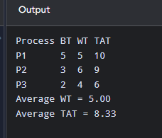
RESULT:
Thus, the Round Robin CPU Scheduling algorithm was successfully implemented using a C program.

